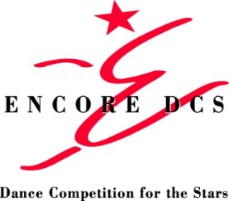
ENCORE DCS Regional Competition
Tentative Schedule Outline
MYRTLE BEACH, SC
MYRTLE BEACH HIGH SCHOOL
FEBRUARY 7-9, 2020

FRIDAY, FEBRUARY 7
5:15 PM DOORS OPEN
6:15 PM JUNIOR SOLOS
10:00 PM JUNIOR DUET/TRIOS
11:05 PM AWARDS CEREMONY

SATURDAY, FEBRUARY 8
6:45 AM DOORS OPEN
7:30 AM MINI AND PETITE SOLOS
8:45 AM MINI AND PETITE DUET/TRIOS
9:15 AM AWARDS CEREMONY
9:40 AM MINI, PETITE AND JUNIOR GROUPS
1:35 PM AWARDS CEREMONY
2:20 PM TEEN PRODUCTIONS
2:45 PM TEEN GROUPS
7:05 PM FREE MASTER CLASS ON STAGE
7:25 PM AWARDS CEREMONY
8:15 PM RECREATIONAL TEEN AND SENIOR SOLOS
10:15 PM ALL SENIOR DUET/TRIOS
11:15 PM AWARDS

SUNDAY, FEBRUARY 9
6:45 AM DOORS OPEN
7:30 AM COMPETITIVE AND ELITE TEEN SOLOS
11:10 AM TEEN DUET/TRIOS
12:55 PM AWARDS CEREMONY
1:30 PM SENIOR GROUPS
4:45 PM AWARDS CEREMONY
5:15 PM COMPETITIVE AND ELITE SENIOR SOLOS
9:15 PM AWARDS CEREMONY

* Please note this is a tentative schedule and is subject to change. A customized schedule with individual performance times for each entry will be emailed to all studios by WEDNESDAY, JANUARY 29. Students should be prepared to compete up to one hour ahead of their scheduled performance time.
** The deadline for changes is FRIDAY, JANUARY 31 and can be emailed to susan@encoredcs.com.
LIVESTREAM AVAILABLE AT WWW.LIVESTREAM.COM/ENCORESOUTH

